HACETTEPE UNIVERSITY
DEPARTMENT OF ELECTRICAL AND ELECTRONICS ENGINEERING
ELE 432: Advanced Digital Design
Homework 2
Hakan Töre
2210357024

- I have spent 5 hours on this homework. Although most of the time was spent on figuring out why the ALUControl values were off in the questa transcript. The controller.tv test vector file was wrong and did not match the architectrue given to us by this course so we had to update the test vectors.

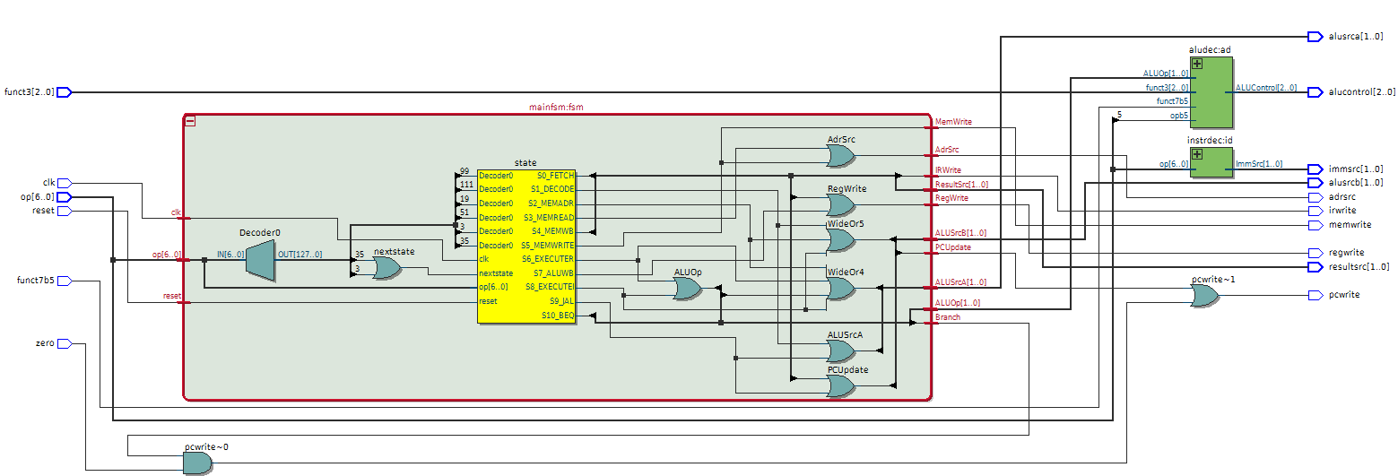
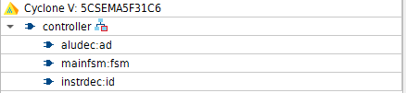

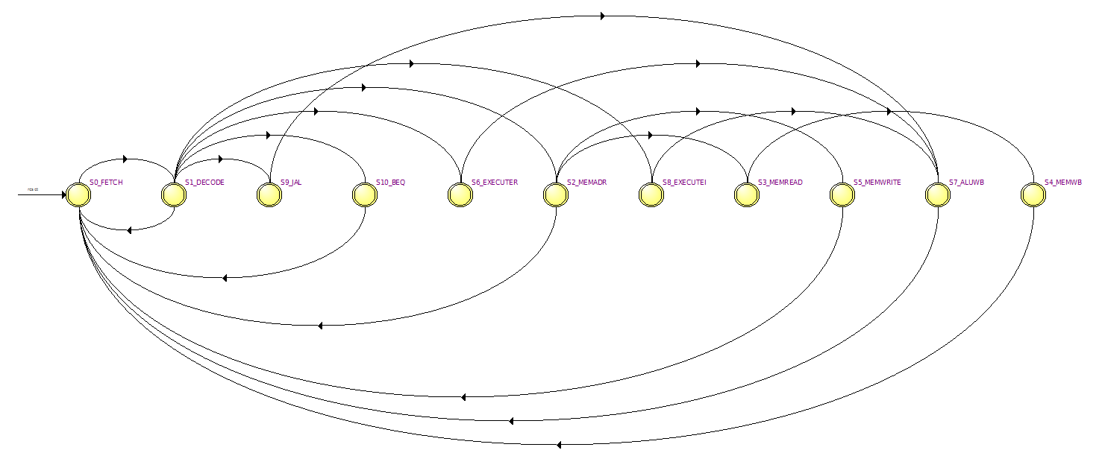

/*
Hakan Töre 2210357024
ELE432 Homework 2 : HW2_Multi-Cycle_RISC-V_Processor
controller.sv
*/
module controller(
input logic clk,
input logic reset,
input logic [6:0] op,
input logic [2:0] funct3,
input logic funct7b5,
input logic zero,
output logic [1:0] immsrc,
output logic [1:0] alusrca, alusrcb,
output logic [1:0] resultsrc,
output logic adrsrc,
output logic [2:0] alucontrol,
output logic irwrite, pcwrite,
output logic regwrite, memwrite
);

logic [1:0] aluop;
logic branch;
logic pcupdate;

assign pcwrite = pcupdate | (branch & zero);

instrdec id (
.op(op),
.ImmSrc(immsrc)
);

aludec ad (
.opb5(op[5]),
.funct3(funct3),
.funct7b5(funct7b5),
.ALUOp(aluop),
.ALUControl(alucontrol)
);

mainfsm fsm (
.clk(clk),
.reset(reset),
.op(op),
.Branch(branch),
.PCUpdate(pcupdate),
.RegWrite(regwrite),
.MemWrite(memwrite),
.IRWrite(irwrite),
.ResultSrc(resultsrc),
.ALUSrcA(alusrca),
.ALUSrcB(alusrcb),
.AdrSrc(adrsrc),
.ALUOp(aluop)
);

endmodule

/*
Hakan Töre 2210357024
ELE432 Homework 2 : HW2_Multi-Cycle_RISC-V_Processor
mainfsm.sv
*/

module mainfsm (
input logic clk,
input logic reset,
input logic [6:0] op,
output logic Branch,
output logic PCUpdate,
output logic RegWrite,
output logic MemWrite,
output logic IRWrite,
output logic [1:0] ResultSrc,
output logic [1:0] ALUSrcA,
output logic [1:0] ALUSrcB,
output logic AdrSrc,
output logic [1:0] ALUOp
);

// State Encoding
typedef enum logic [3:0] {
S0_FETCH = 4'b0000,
S1_DECODE = 4'b0001,
S2_MEMADR = 4'b0010,
S3_MEMREAD = 4'b0011,
S4_MEMWB = 4'b0100,
S5_MEMWRITE = 4'b0101,
S6_EXECUTER = 4'b0110,
S7_ALUWB = 4'b0111,
S8_EXECUTEI = 4'b1000,
S9_JAL = 4'b1001,
S10_BEQ = 4'b1010
} statetype;

statetype state, nextstate;
// State Register
always_ff @(posedge clk or posedge reset) begin
if (reset) state <= S0_FETCH;
else state <= nextstate;
end

// Next State Logic
always_comb begin
case (state)
S0_FETCH: nextstate = S1_DECODE;
S1_DECODE: begin
case (op)
7'b0000011: nextstate = S2_MEMADR; // lw
7'b0100011: nextstate = S2_MEMADR; // sw
7'b0110011: nextstate = S6_EXECUTER; // R-type
7'b0010011: nextstate = S8_EXECUTEI; // I-type ALU
7'b1101111: nextstate = S9_JAL; // jal
7'b1100011: nextstate = S10_BEQ; // beq
default: nextstate = S0_FETCH;
endcase
end
S2_MEMADR: begin
case (op)
7'b0000011: nextstate = S3_MEMREAD; // lw
7'b0100011: nextstate = S5_MEMWRITE; // sw
default: nextstate = S0_FETCH;
endcase
end
S3_MEMREAD: nextstate = S4_MEMWB;
S4_MEMWB: nextstate = S0_FETCH;
S5_MEMWRITE: nextstate = S0_FETCH;
S6_EXECUTER: nextstate = S7_ALUWB;
S7_ALUWB: nextstate = S0_FETCH;
S8_EXECUTEI: nextstate = S7_ALUWB;
S9_JAL: nextstate = S7_ALUWB;
S10_BEQ: nextstate = S0_FETCH;
default: nextstate = S0_FETCH;
endcase
end

// Output Logic
always_comb begin
// When outputs are don’t care, set them to 0
Branch = 1'b0;
PCUpdate = 1'b0;
RegWrite = 1'b0;
MemWrite = 1'b0;
IRWrite = 1'b0;
ResultSrc = 2'b00;
ALUSrcA = 2'b00;
ALUSrcB = 2'b00;
AdrSrc = 1'b0;
ALUOp = 2'b00;

case (state)
S0_FETCH: begin
AdrSrc = 1'b0;
IRWrite = 1'b1;
ALUSrcA = 2'b00;
ALUSrcB = 2'b10;
ALUOp = 2'b00;
ResultSrc = 2'b10;
PCUpdate = 1'b1;
end
S1_DECODE: begin
ALUSrcA = 2'b01;
ALUSrcB = 2'b01;
ALUOp = 2'b00;
end
S2_MEMADR: begin
ALUSrcA = 2'b10;
ALUSrcB = 2'b01;
ALUOp = 2'b00;
end
S3_MEMREAD: begin
ResultSrc = 2'b00;
AdrSrc = 1'b1;
end
S4_MEMWB: begin
ResultSrc = 2'b01;
RegWrite = 1'b1;
end
S5_MEMWRITE: begin
ResultSrc = 2'b00;
AdrSrc = 1'b1;
MemWrite = 1'b1;
end
S6_EXECUTER: begin
ALUSrcA = 2'b10;
ALUSrcB = 2'b00;
ALUOp = 2'b10;
end
S7_ALUWB: begin
ResultSrc = 2'b00;
RegWrite = 1'b1;
end
S8_EXECUTEI: begin
ALUSrcA = 2'b10;
ALUSrcB = 2'b01;
ALUOp = 2'b10;
end
S9_JAL: begin
ALUSrcA = 2'b01;
ALUSrcB = 2'b10;
ALUOp = 2'b00;
ResultSrc = 2'b00;
PCUpdate = 1'b1;
end
S10_BEQ: begin
ALUSrcA = 2'b10;
ALUSrcB = 2'b00;
ALUOp = 2'b01;
ResultSrc = 2'b00;
Branch = 1'b1;
end
endcase
end
endmodule

// Output Logic
always_comb begin
// When outputs are don’t care, set them to 0
Branch = 1'b0;
PCUpdate = 1'b0;
RegWrite = 1'b0;
MemWrite = 1'b0;
IRWrite = 1'b0;
ResultSrc = 2'b00;
ALUSrcA = 2'b00;
ALUSrcB = 2'b00;
AdrSrc = 1'b0;
ALUOp = 2'b00;
case (state)
S0_FETCH: begin
AdrSrc = 1'b0;
IRWrite = 1'b1;
ALUSrcA = 2'b00;
ALUSrcB = 2'b10;
ALUOp = 2'b00;
ResultSrc = 2'b10;
PCUpdate = 1'b1;
end
S1_DECODE: begin
ALUSrcA = 2'b01;
ALUSrcB = 2'b01;
ALUOp = 2'b00;
end
S2_MEMADR: begin
ALUSrcA = 2'b10;
ALUSrcB = 2'b01;
ALUOp = 2'b00;
end
S3_MEMREAD: begin
ResultSrc = 2'b00;
AdrSrc = 1'b1;
end
S4_MEMWB: begin
ResultSrc = 2'b01;
RegWrite = 1'b1;
end
S5_MEMWRITE: begin
ResultSrc = 2'b00;
AdrSrc = 1'b1;
MemWrite = 1'b1;
end
S6_EXECUTER: begin
ALUSrcA = 2'b10;
ALUSrcB = 2'b00;
ALUOp = 2'b10;
end
S7_ALUWB: begin
ResultSrc = 2'b00;
RegWrite = 1'b1;
end
S8_EXECUTEI: begin
ALUSrcA = 2'b10;
ALUSrcB = 2'b01;
ALUOp = 2'b10;
end
S9_JAL: begin
ALUSrcA = 2'b01;
ALUSrcB = 2'b10;
ALUOp = 2'b00;
ResultSrc = 2'b00;
PCUpdate = 1'b1;
end
S10_BEQ: begin
ALUSrcA = 2'b10;
ALUSrcB = 2'b00;
ALUOp = 2'b01;
ResultSrc = 2'b00;
Branch = 1'b1;
end
endcase
end
endmodule

aludec.sv instrdec.sv and controller_testbench.sv were given to us by default there were no changes done to them but I have changed the test vectors controller.tv

- The controller.tv file was using a RISC-V standard different that the one in the Harris & Harris book and the homework file. I updated the expected ALUControl bits to match the Harris & Harris’s description. The updated file can be found in the GitHub repository.
Example:
//op[6:0]_funct3[2:0]_funct7b5_Zero_ImmSrc[1:0]_ALUSrcA[1:0]_ALUSrcB[1:0]_ResultSrc[1:0]_AdrSrc_ALUControl[2:0]_IRWrite_PCWrite_RegWrite_MemWrite
// add
old | updated
0110011_000_0_0__XX_00_10_10_0_010_1_1_0_0 // Fetch  0110011_000_0_0__XX_01_01_00_0_010_0_0_0_0 // Decode 0110011_000_0_0__XX_10_00_00_0_010_0_0_0_0 // ExecuteR 0110011_000_0_0__XX_00_00_00_0_010_0_0_1_0 // ALUWB | 0110011_000_0_0__XX_00_10_10_0_000_1_1_0_0 // Fetch  0110011_000_0_0__XX_01_01_00_0_000_0_0_0_0 // Decode  0110011_000_0_0__XX_10_00_00_0_000_0_0_0_0 // ExecuteR  0110011_000_0_0__XX_00_00_00_0_000_0_0_1_0 // ALUWB
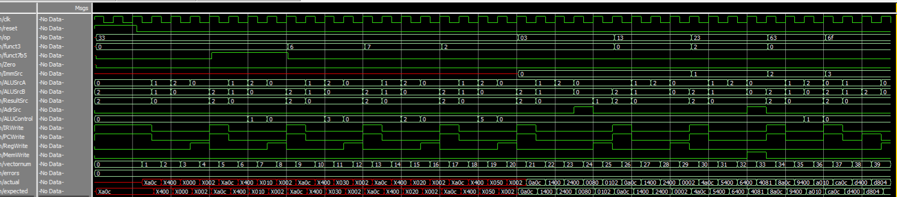

As you can see from the error counter there is no errors

https://github.com/Hakan-26/-Multicycle-Processor-Controller

